1. **Timeline of remaining tasks and who is leading each task**

**APRIL 2 – APRIL 17:**

|  |  |
| --- | --- |
| **Division of Tasks** | |
| Michael | Find and implement more useful feature extractions:   * Delete random features the Random Forest Classifier generated * Learn and implement a principal component analysis (PCA) |
| Nikita | Delve into PyTorch & help find more features:   * Learn how ORB works on a more in-depth level so we can tweak any parameters to make it better suited for our algorithm |
| Rosemond | Delve into PyTorch and use another classifier:   * Look into the implementation of a CNN * Try to implement it and compare the results with the Ran. Forest |
| Trung | Image preprocessing upgrade:   * Rework preprocessing to account to monochromatic images * Think about how to tackle the issue of off-center hands and possible solutions to solve it |

**APRIL 18:** ONE PAGE PROGRESS REPORT DUE.

**APRIL 19 – APRIL 22:**

|  |  |
| --- | --- |
| **Division of Tasks** | |
| Michael | Code integration:   * After finding another feature to extract and possibly have a CNN implemented; incorporate the preprocessing and run training/testing * Compare results, discuss and create a plan to move forward, possibly scrapping certain features or parts of the preprocessing |
| Nikita | Get more training data:   * After training on all the provided, find new fresh data online or create new ones that might throw off the algorithm and add it to the test set |
| Rosemond | Code integration:   * Ensure that none of our classifiers are overfitting the data by running more test where data is swapped out/in |
| Trung | Compile list of false positives and false negatives.   * Sort through the images, see where preprocessing may have failed * Find ways to account for it if possible, keeping overfitting in mind |
| All | Report & Presentation   * Create report detailing our methods and results * Step-by-step on how and why images are processed * Generate charts and graphs to represent results * Create PowerPoint presentation of methods and findings |

**APRIL 23:** IN CLASS PROJECT COMPETITION. PROJECT REPORT DUE.

1. **Summary of performance of current system (with update results shown)**

Our current implementation of our system utilizes the KNN and Random Forests classifier. In both cases we explored a monocratic filter that highlights the lines in the hands and creates a better contrast between the hand and background. In addition to this, we also performed a transformation from RGB to HSV on our images. By specifically using the saturation characteristic of an image, we had a better means of differentiating the hand from the background as well. Upon having an effective means to filter the hand from background, our results are as shown.

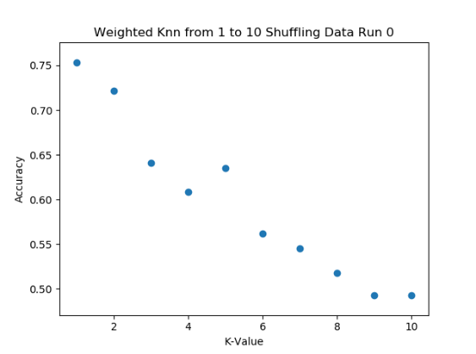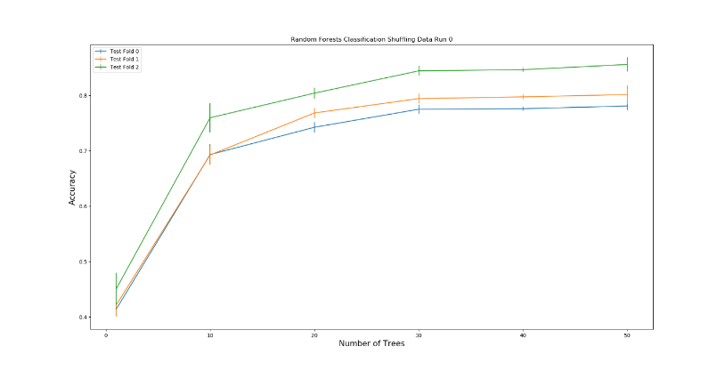

Our Random Forest classifier performed more consistently and yielded a higher accuracy than our KNN algorithm. As a result, we will continue to use the random forest classifier and not the KNN.

1. **Detailed plan and discussion of how you will avoid overfitting**

First, we will supplement our dataset with other ASL datasets online. We will perform all the necessary modifications of the images such as rescale and processing steps to ensure the usability of the images within our current system. Using this new data and the provided class data, we will also perform cross validation and ensure we are correct on even worst-case images. For example, we will train on images that mostly have a white background and then test it using images that have shadows and noisy backgrounds where the color may not be white.

Second, we will try to minimize and remove unneeded dimensions of the data to lower the degrees of freedom. If we see that

1. **Any other updates that you would like to include**

We were pleasantly surprised by the performance of our system. It is possible that the diversity amongst our group members contributed to a better operation and high classification accuracy. However, we will continue to be diligent in our approach and not assume that our final performance will necessarily parallel our preliminary trials. One of the ways we will tackle this issue is by exploring other classifier methods such as a convolutional neural network.

Furthermore, we will investigate Pytorch and decided if we should make that change to it permanently or continue to use Sci-kit image.

1. **Also provide a percentage of effort from everyone in the team (e.g., Alice - 70% of effort so far; Bob - 20% of effort so far; Carl - 10% of effort so far) You should all agree on this. This will affect your grade if there are individuals that are not pulling their weight. If everyone is contributing equally, it should be equal percentages.**

|  |  |
| --- | --- |
| **Team Member** | **Percent** |
| Rosemond Fabien | 30% |
| Trung Tran | 31% |
| Michael Barnard | 31% |
| Nikita Buslov | 8% |